**Compound Index :**

MongoDB supports compound indexes, where a single index structure holds references to multiple fields [1] within a collection's documents.

**Create a Compound Index**

To create a compound index use an operation that resembles the following prototype:

db.collection.createIndex( { <field1>: <type>, <field2>: <type2>, ... }

Let us start the mongo :-

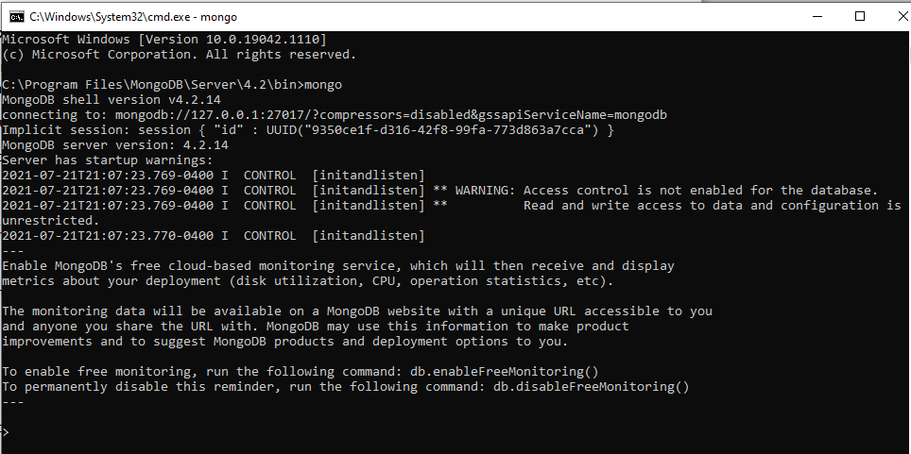

Once mongo is up and running, next step is switch to database. And use collection .

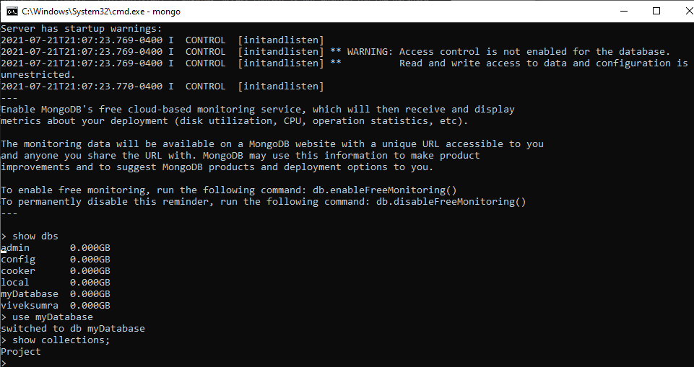

db.Project.findOne()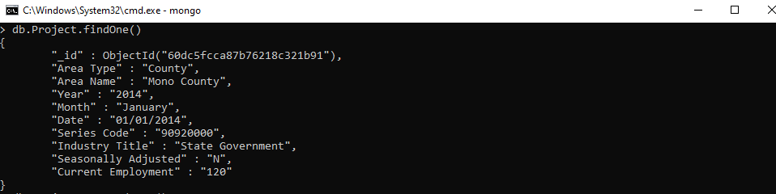

Let us see if we have any existing indexes

db.Project. getIndexes()

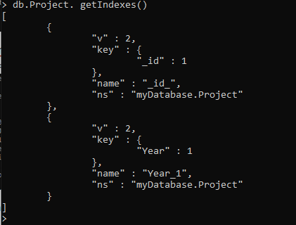

As you can clearly see from the screenshot, we have a index based on Year column.

db.Project.find({"Year": "2014"})

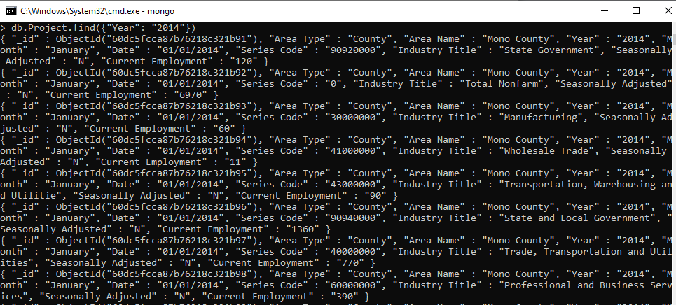

Now Let us try to explain

db.Project.find({"Year": "2014"}).explain("executionStats")

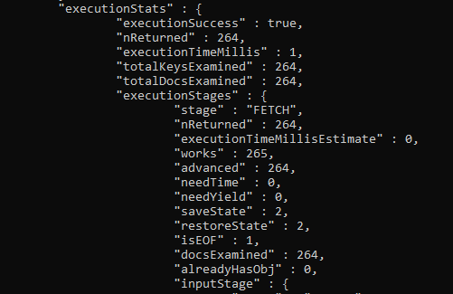

Hence due to index created only 264 documents out of total documents are examined.

Since our data set is having total of 10 columns , we can create compound index based on any of the columns.

db.Project.createIndex({'Year': 1, 'Month':1})

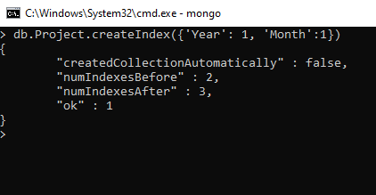

We can also list the compound index created just now using following command :-

db.Project. getIndexes()

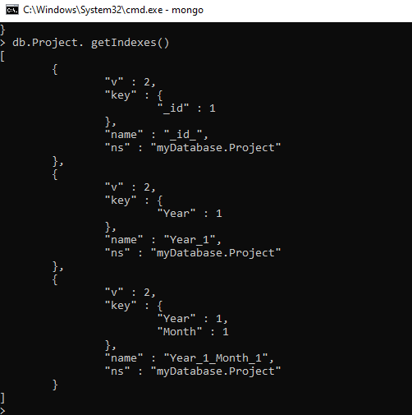

Since we were working on number of datasets for our project and we need to analyze that data sets even further to choose which columns on which we can create compound indexes.

We will try to proceed with sharding part for time being .